**Project Title:**

**TaskMaster Description:**

TaskMaster is een to-do applicatie waarmee gebruikers hun taken kunnen organiseren, prioriteren, en bijhouden. Gebruikers kunnen eenvoudig nieuwe taken aanmaken, bestaande taken bekijken, bewerken en verwijderen. Elke taak kan worden voorzien van een prioriteit en tags voor extra organisatie. Gebruikers kunnen hun taken filteren op basis van status (voltooid/niet voltooid). Met TaskMaster kunnen gebruikers hun productiviteit verbeteren door hun dagelijkse taken effectief te beheren.

**User Story 1: View Task List / Details**

**As a** user,  
**I'm able to** view a list of all my tasks,  
**So that I can** quickly see what I need to work on.

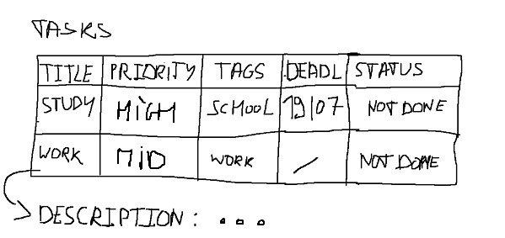

**Acceptance Criteria**:

* The user can see a list of all task
* Each task displays its title, priority, tags, and status.
* The user can click on a task to view its description

**User Story 2: Add a Task**

**As a** user,  
**I'm able to** add a new task with details like title, description, priority, deadline, tags, and status,  
**So that I can** keep track of my upcoming work and organize my tasks efficiently.

**Acceptance Criteria**

* The user can add a new task by filling in the required fields.
* The "Save" button adds the new task to the task list.
* The "Cancel" button clears the form and navigates back to the task list.
* Task information (title, description, priority, deadline, tags, and status) is correctly saved and displayed in the task list.

**User Story 3: Edit a Task**

**As a** user,  
**I'm able to** edit an existing task's details such as title, priority, tags, and status,  
**So that I can** update tasks when information or priorities change.

**Acceptance Criteria**

* The user can open a task for editing by clicking an "Edit" button next to the task in the task list.
* The form is pre-filled with the task's existing information.
* The user can modify the task's title, priority, tags, deadline and description.
* The "Update" button saves changes to the task and updates the task list.
* The "Cancel" button discards any changes and returns the user to the task list without modification.

**User Story 4: Delete a Task**

**As a** user,  
**I'm able to** delete an existing task,  
**So that I can** remove tasks that are no longer needed and keep my task list organized.

**Acceptance Criteria**

* The user can click a "Delete" button next to any task in the list.
* A confirmation dialog appears to prevent accidental deletions.

**User Story 5: Mark a Task as Completed**

**As a** user,  
**I'm able to** mark a task as completed,  
**So that I can** track which tasks have been finished and differentiate them from ongoing tasks.

**Acceptance Criteria**

* The user can mark a task as completed by clicking on the status of the task.

**User Story 6: Filter Tasks**

**As a** user,  
**I'm able to** filter tasks based on their status, title, priority and deadline,   
**So that I can** easily view tasks that meet my requirements.

**Acceptance Criteria**

* The user can filter tasks using a dropdown or toggle at the top of the task list.

**User Story 7: Reminder for Task Deadlines**

**As a** user,  
**I’m able to** set a reminder so that I now when the deadline is approaching,  
**So that** I can complete my tasks on time and stay organized.

**Acceptance Criteria:**

* The system will send a notification (via email, push, or in-app) when the task's reminder time is reached.